
.

Anti-Bullying Charter
At Golden Valley Primary School everybody has the right to feel safe, be treated with respect and be treated kindly. Everyone should feel valued for their differences.
We agree to:
- Make people feel welcome
- Treat others with respect
- Think before we speak because words can be hurtful
- Support each other, especially others who are feeling sad
- Share smiles because they make other people smile
- Share kindness with people
- Include people so that they don’t feel left out of games or activities
- Talk to people who have chosen to sit on the buddy bench because they are feeling lonely
- Take responsibility for our own actions and be prepared to compromise and share
- Ensure that our behaviour online is kind, respectful and safe at all times
- Share our problems with trusted adults so that they can sort them out
- Share with an adult if we are feeling sad or we see something we feel uncomfortable with
- Take all bullying seriously and report it to an adult
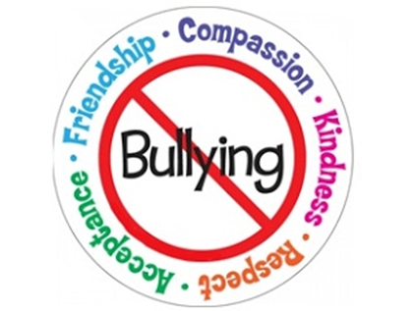
November 2025

